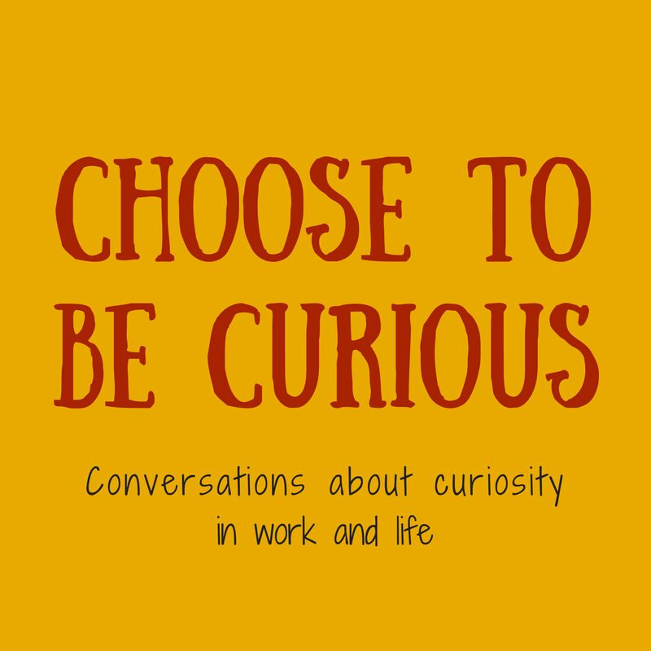

Choose to be Curious is all about curiosity.
We talk about research and theory,
but mostly it’s conversations about
how curiosity shows up in work and life.

PRODUCER & HOST: Lynn Borton
EMAIL: choosetobecurious@gmail.com WEBSITE: choosetobecurious.com
FACEBOOK/THREADS/INSTAGRAM/POST: @choosetobecurious
PODCAST: Apple Podcasts/iTunes Spotify & anywhere else you get your podcasts: /choosetobecurious
Now available via Pacifica Radio Network - https://audioport.org

SEASON ONE:
001: Education & Learning with Micaela Pond, Arlington Public Schools teacher (May 4, 2016)
002: Journalism with Drew Costley, Falls Church Press news editor (May 18, 2016)
003: This Is Your Brain on Curiosity with Dr. Jill Bolte Taylor, neuroanatomist (June 2, 2016)
004: Cultivating a Holy Curiosity with Revs. Carolyn Richar & Junsen Nettles (June 16, 2016)
005: Creativity with A.J. Smith , musician and songwriter (June 29, 2016)
006: More and More Beautiful Questions with Beth Flores, intrapreneur (July 13, 2016)
007: Curiosity, Comics & the CIA with Tom King, writer, Batman comic books (July 27, 2016)
008: Body Awareness & Yoga with Jenn Seiff, Om Joy Yoga (Aug. 10, 2016)
009: The Case of the Curious Detective with Det. Sarah Bertollini, Arlington County Police (Aug. 31, 2016)
010: Empathy with Brandon Charles, Breaking Boundaries (Sept. 7, 2016)
011: Trauma & Incarceration with Elizabeth Jones, Offender Aid & Restoration, Inc. (Sept. 22, 2016)
012: Leadership with Scott Nycum, CSRA (Oct. 6, 2016)
013: Science & Research with Kelly Falkner, National Science Foundation (Oct. 21, 2016)
014: Narrative Medicine with Dr. Raya Kheirbek, DC Veterans Affairs (Nov. 3, 2016)
015: Challenging Racism with Marty Swaim & Monique Brown, Challenging Racism (Nov. 16, 2016)
016: Improv with Jesse Robinson, The ProvCast (Nov. 30, 2016)
017: Me on Curiosity, PictureLocks’ Kevin Sampson turns the tables and interviews me (Dec. 14, 2016)
018: Conflict Resolution/Megan Price, GMU School for Conflict Analysis & Resolution (Dec. 30, 2016)
019: Adolescence with Kate McCauley & Michael Swisher (Jan. 12, 2017)
020: Gender Identity with Evie & Sarah Priestman (Jan. 25, 2017)
021: Evaluation with Carlisle Levine, BLE Solutions (Feb. 8, 2017)
022: Immigration with Anderson Escobar & Meriami Shengelia, Liberty’s Promise (Feb. 22, 2017)
023: News Literacy with Patricia Hunt, Wakefield High School teacher (March 8, 2017)
024: Curiosity & the Farmers Market (March 22, 2017)
025: Early Childhood with Kate Graham, Arlington Public Schools (April 5, 2017)
026: Challenging Racism, Part 2 with Monique Brown, Challenging Racism (April 19, 2017)
SEASON TWO:
027: Trust with Scott Nycum, CSRA (May 3, 2017)
028: Writing Fiction with Laura McBride, teacher and author (May 17, 2017)
029: Curiosity Across Political Distance with Stacy Snyder, Together Virginia (May 31, 2017)
030: Checking Out Curiosity at the Library with Jennifer Rothschild, Arlington Public Library (June 14, 2017)
031: Entrepreneurial Spirit with Ximena Hartsock, founder, Phone2Action (June 28, 2017)
032: Is Curiosity Feminine? With Tonya Howe PhD, Marymount University (July 12, 2017)
033: Placemaking with Graham Coreil-Allen, New Public Sites (July 26, 2017)
034: Curious & Not Old with Marjorie Varner, Encore Learning (Aug. 9, 2017)
035: What in the World? With Bunmi Akinnusotu, What in the World? Radio & Podcast (Aug. 23, 2017)
036: Building Bridges with Vivek Patil, Building Bridges (Sept. 6, 2017)
037: RV Curious? with Laine Coates, former AIM staffer, now RV traveler (Sept. 20, 2017)
038: Find One’s Calling with Mohamed Ali, creative human enabler (Oct. 4, 2017)
039: Networking with Dana Theus, InPower Coaching (Oct. 18, 2017)
040: #MyCuriousEyes with Karen Ward, Curiosity, Inc. (Nov. 1, 2017)
041: Skepticism, or Is It? with Keris Myrick (Nov. 15, 2017)
042: #Analogy: A Tribute, upon the death of the first Big Jar of Wannabe Analogies (Nov. 29, 2017)
043: Oral History with Valeria Gelman, The Local Shop (Dec. 13, 2017)
044: Comedy Is About Observation / Felonious Munk, Calvin Evans & Odinaka Ezeokoli (Dec. 29, 2017)
045: What Makes Us Curious? With Dr. Mario LIvio, astrophysicist and author (Jan. 10, 2018)
046: Sondra’s Story: You Can’t Help But Want to Know, finding my mother-in-law’s father (Jan. 24, 2018)
047: Transformative Power of Attention with Caetlin Benson-Allott, Georgetown Univ. (Feb. 7, 2018)
048: Curious & Wondrous Travel with Elliot Carter, Atlas Obscura (Feb. 21, 2018)
049: Curiosity, Big Data & The Flu, with Dr. Naren Ramakrishnan, Discovery Analytics Center (March 7, 2018)
050: Walking the Curiosity Talk, highlights of 50 hours spent in celebration of 50 episodes (March 21, 2018)
051: Curiosity & Ethics Consultation with Dr. Ellen Fox, Fox Ethics Consulting (April 4, 2018)
052: Curiously Green with Miriam Gennari, Styrofoam Mom (April 18, 2018)

SEASON THREE:
053: Double Take on Lynching with Susan Strasser & Marcia Cole, historian & poet join forces (May 2, 2018)
054: How to Change the World, Central Falls High School (RI) students in the nation’s capital (May 16, 2018)
055: Lessons Learned with Sharon Shutler, an advocate reflects on what worked & what didn’t (May 30, 2018)
056: Curiosity & the Craving Mind with Dr. Judson Brewer, Brown University & TEDTalk star (June 13, 2018)
057: Listening Well with Jocelyn Frank, DC Listening Lounge & Sound Scene (June 27, 2018)
058: Curiosity & Infidelity with The Chump Lady, Tracy Schorn (July 11, 2018)
059: Curiosity, Craft & Creativity with Matthew Cronin, professor of management, GMU (July 25, 2018)
060: Celebrity with Dean Rogers, The Rogers Revue, entertainment news (Aug. 8, 2018)
061: Student-Led Research with Shane McCarty , Yorktown High School AP Psych students (Aug. 22, 2018)
062: Curiosity & A Big Book - #OhBoyTolstoy, Arlington Public Library’s 2018 Big Book Club (Sept., 5, 2018)
063: Curiosity Is Political, with Perry Zurn, professor of philosophy, American University (Sept. 19, 2018)
064: Bias, with filmmaker Robin Hauser, documentary filmmaker takes on implicit bias (Oct. 3, 2018)
065: Capturing the Bandwidth of Curiosity, with Todd Kashdan, researcher/psychologist, GMU (Oct. 17, 2018)
066: Current Affairs, Kids & Curiosity, with Andrea Cambron, Enlighten Me, WERA (Oct. 31, 2018)
067: Curiosity’s Part in Theater Arts, with Stan Kang, Educational Theatre Company (Nov. 14, 2018)
068: Courtesy of Curiosity, with Rebecca Czarniecki, Tea With Mrs. B (Nov. 28, 2018)
069: A Capital Naturalist, with Alonso Abugattas, Capital Naturalist (Dec. 12, 2018)
070: Animal Curiosity at the National Zoo (Dec. 26, 2018)
071: Point of View, with Photographer Jason Horowtiz, Jason Horowitz Fine Art Photography (Jan. 9, 2019)
072: Curious About Our Roots, with Wilma Jones, author of My Halls Hill Family (Jan. 23, 2019)
073: Curiosity in Support of Equity, with Christian Dorsey, Arlington County Board chair (Feb. 6, 2019)
074: Neuroscience Eyes Curiosity, with Dr. Jacqueline Gottlieb, Columbia University (Feb. 20, 2019)
075: Curiosity & the Law, with Palma Strand, law professor, Creighton University (March 6, 2019)
076: Curiosity on the Menu, with Noobtsaa Vang, entrepreneur & founder, Foodhini (March 20, 2019)
077: Taking Curiosity in Stride, with WalkArlington (April 3, 2019)
078: Putting Curiosity on the Map, with Allison Davis-Holland, cartographer (April 17, 2019)

SEASON FOUR:
079: Curiosity & Sex Ed, with Jacomina de Regt, facilitator, Our Whole Lives “OWL” (May 1, 2019)
080: The Right Question Institute, with Andrew Minigan, director of strategy (May 15, 2019)
081: Curiosity is the Gateway to Connection, with Mike Morales (May 29, 2019)
082: What Is a Question, with Lani Watson, PhD, philosopher, University of Edinburgh (June 12, 2019)
083: Curiosity & Collecting, with Barbara M. Benedict, English lit professor, Trinity College (June 26, 2019)
084: Can We Choose to be Curious? with Asia Ferrin, professor of philosophy, American Univ. (July 10, 2019)
085: Ethnography & Cultures of Curiosity, with John L. Jackson, Jr., Annenberg School, UPenn (July 24, 2019)
086: Diversity, Inclusion & Curiosity, with Karen Coltrane, Leadership Center for Excellence (Aug. 7, 2019)
087: Reassessing the Costs of Curiosity, with Seeta Sistla, Hampshire College (Aug. 21, 2019)
088: Why Count: Curiosity & Census 2020, with Elizabeth Hardy, Arlington County Planning (Sept. 3, 2019)
089: In Praise of Distraction, with Tyson Lewis, University of North Texas (Sept. 17, 2019)
090: Storytelling: A Curious Tale, with Ronald Young, Jr., podcaster Time Well Spent (Sept. 25, 2019)
091: Curiosity & Philanthropy, Sonia Quiñónez, Eugene & Agnes E. Meyer Foundation (Oct. 2, 2019)
092: On Being a Curious Maker, with Henry Dunbar, maker & upcycler (Oct. 9, 2019)
093: Curios & Curiotizing, with Trans Scholar Amy Marvin, (Oct. 16, 2019)
094: Designing for Curiosity, with HyunJoo Oh, Georgia Tech (Oct. 23, 2019)
095: Censorship: Curiosity Curtailed, with Molly Roberts, UC San Diego (Oct. 30, 2019)
096: Curiosity & Racist Mindsets, with Narendra Keval, London psychologist & psychoanalyst (Nov. 13, 2019)
097: Curiosity, Values and Financial Planning, with Rebecca Borton, Concentric Wealth, (Nov. 20, 2019)
098: Cultivating Cultural Intelligence, with Asma Ahmad, founder, Zaha (Nov. 27, 2019)
099: Neurodiverse Curiosity, with Kristy Johnson, MIT Media Lab (Dec. 11, 2019)
100: Everyday Curiosity, with David Lydon-Staley, UPenn (Dec. 18, 2019)
101: Curiosity, Trust and Homebuying, with Realtor Christine Hopkins (Dec. 25, 2019)
102: Reflections-Not-Resolutions, with Kristine Wood, Facilitator & Trainer, Core Skill LLC (Jan. 1, 2020)
103: Why Should This Be So? with Susan Engel Ph.D., Williams College (Jan. 8, 2020)
104: Curiosity & Non-Obvious Thinking, with Rohit Bhargava, author & marketing expert (Jan. 15, 2020)
105: Dance & Embodied Curiosity, with Erin Foreman-Murray, American University (Jan. 22, 2020)
106: Build a Better Shoe, with Casey Kerrigan, M.D., founder OESH Shoes (Jan. 29, 2020)
107: Capitalist Curiosity & Student Mental Health, with Arjun Shankar, PhD, Colgate (Feb. 5, 2020)
108: Greg Hamilton Just Wanted to Know Stuff, publisher, Arlington Magazine (Feb. 12, 2020)
109: Curiosity & Health Advocacy, with Nicole Rochester, M.D., founder, Your GPS Doc, (Feb. 19, 2020)
110: Curiosity in Service of Bipartisanship, with Bob Mitchell, Bipartisan Leadership Project (March 4, 2020)
111: Network Systems: Connecting the Dots with Dani Bassett, UPenn (March 11, 2020)
112: A Curious Crew: Curiosity & The Community College Initiative (March 18, 2020)
113: (Re)Creating Community, with Ashley Goff, Arlington Presbyterian Church (March 25, 2020)
114: Resilient & Brave, with Dr. Jill Bolte Taylor, brain scientist (April 1, 2020)
115: Curiosity Studies, with Perry Zurn, PhD, American University (April 15, 2020)
116: Voicing Curiosity, with Carol Cadby, educator, actor, director, coach (April 29, 2020)

SEASON FIVE:
117: Curious Entanglements, with Christina León, Princeton University (May 13, 2020)
118: Appreciative Inquiry, with Tojo Thatchenkery, George Mason University (May 27, 2020)
119: James Danckert Is Curious About Boredom, University of Waterloo (June 10, 2020)
120: Curiosity & the Digital Transgender Archive, with KJ Rawson, founder and director (June 24, 2020)
121: Curiosity & A Seat at the Table, with Krysta Jones, founder Vote. Lead. Impact. (July 8, 2020)
122: CuriosityConnects.Us with Philippa Hughes, social sculptor and activist (July 22, 2020)
123: Sounds of Caring, with Yoko Sen & Tammy Beaulieu, reflections from COVID frontlines (Aug. 5, 2020)
124: Curiosity & Education Equity, with Ryoko Reed, education/equity advocate (Aug. 19, 2020)
125: Curiosity Out on the Town, with Demian Perry, founder TownCalendar.com (Sept. 2, 2020)
126: Imagining Worlds Otherwise: Learning from Black Feminist Curiosity, Ayanna Spencer (Sept. 16, 2020)
127: The News Literacy Project, with Ebonee Rice, News Literacy Project (Sept. 30, 2020)
128: Solitude, with Poet David Keplinger, American University (Oct. 14,2020)
129: The Inquiring Minds Behind Science Writing, with Kim O’Connell, writer/teacher (Oct. 28, 2020)
130: Ode to Crows, with Colleen & John Marzluff, University of Washington (Nov. 11, 2020)
131: Neighboring, with Alli Henry, Community Planning, Rosslyn BID (Nov. 25, 2020)
132: COVID & the Consequences of Incuriosity, with Dr. Eric Feigl-Ding (Dec. 9, 2020)
133: Curiosity & Helping Each Other, with Kellen MacBeth, founder of Facebook group (Dec. 16, 2020)
134: Curiosity & Learning in Two Languages, with Marleny Perdmoo, Key School (Jan. 6, 2021)
135: Curiosity in the Workplace, with Alison Horstmeyer (Jan. 20, 2021)
136: Dialogues on Race & Equity, with Samia Byrd, Arlington County (Feb. 3, 2021)
137: Dynamic Equilibrium: Curiosity & Color, with Bryan Jernigan, artist (Feb. 17, 2021)
138: Engineering & the Frederick Douglass Memorial Bridge, with Dennis Howland (March 3, 2021)
139: Humble Inquiry for Parents, with Kate McCauley, Center for Parents & Teens (March 17, 2021)
140: Creating Knowledge that Works, with Jason Radford, Volunteer Science (March 31, 2021)
141: Diagnosing Curiosity, with Stefaan van Hooydonk, Global Curiosity Institute (April 14, 2021)
142: Science Thinking, Uncertainty & Kids, with Jamie Jirout, UVA School of Educ. (April 28, 2021)

SEASON SIX:
143: Compassionate Curiosity & Death, with Valoria Walker, Doula by Destiny (May 12, 2021)
144: Curiosity & Peace Building, with Alp Özerdem, Carter School, GMU (May 26, 2021)
145: What If? Counterfactual Curiosity, with Lily FitzGibbon, University of Reading (June 9, 2021)
146: The Montessori Method, with Chandra Fernando, education consultant (June 23, 2021)
147: Rebel Leadership, with Larry Robertson, innovation advisor and author (July 7, 2021)
148: Curiosity & Community Media, with Antoine Haywood, UPenn Annenberg School (July 21. 2021)
149: Studio PAUSE, with Sushmita Mazumdar artist, educator, writer (Aug. 4, 2021)
150: Curiosity in Work & Life, with John Green, educator, entrepreneur, haircutter (Aug. 18, 2021)

151: Reveal: The Art of Reimagining Scientific Discovery, Rebecca Kamen, artist (Sept. 1, 201)

152: Between Improbable & Impossible: Curiosity & Magic, with Mitch Praver, magician (Sept. 15, 2021)

153: Sober Curious, with Laura Silverman, founder, Booze Free in DC (Sept. 29, 2021)
154: Our Man in Arlington, Charlie Clark, journalist, author and historian (Oct. 13, 2021)
155: Morbid Curiosity, with Coltan Schrivner, University of Chicago (Oct. 27, 2021)
156: Curiosity & Community Engagement, with Dulce Carrillo, Arlington Public Schools (Nov. 10, 2021)
157: Reading Our Landscapes, with Liam Heneghan, DePaul University (Nov. 24, 2021)
158: The Courage of Our Questions, with Crys Matthews, social justice music maker (Dec. 8, 2021)
159: Architecting Curiosity; Pim Schachtschabel, Monica Canfield-Lenfest & Anthony Rocco (Dec. 22, 2021)
160: Curiosity in Restorative Justice, with Kimiko Lighty, Restorative Arlington (Jan. 5, 2022)
161: Sanity, with Tanmoy, mental health journalist (Jan. 19, 2022)
162: Solutions Journalism: An Exercise in Curiosity, with Marie von Hafften (Feb. 2, 2022)
163: The Art of Insubordination, with Todd Kashdan, Well-Being Lab, GMU (Feb. 16, 2022)
164: Information Design with Curiosity in Mind, with Alli Torban, information designer (Mar. 2, 2022)
165: Wait…What? Revisiting Curiosity, Race & Healthcare, with Dr. Nicole Rochester (Mar. 16, 2022)
166: Conspiracy Theories, Magical Thinking & Curiosity, with Eric Oliver, University of Chicago (April 6, 2022)
167: Getting to Carbon Neutral with Curiosity, with Helen Reinecke-Wilt, Arlington County (April 20, 2022)

SEASON SEVEN:
168: Paying Attention to Our Bodies, with Eva Meier, The Line Method (May 11, 2022)
169: Michael Tennant is Actually Empathic, Curiosity Lab / Actually Curious card game (May 18, 2022)
170: Spiritually Curious, with Rev. Bryant Oskvig, American University (June 1, 2022)
171: Blending & Normalizing: Curiosity, Quilts & Juneteenth, with Andi Cullins, textile artist (June 15, 2022)
172: Curiosity, Gamification & Capital Clues, with Erik Neighbour, ed-tech founder (June 29, 2022)
173: Query the Work, with Writer Liz Coley, author & playwright (July 13, 2022)
174: Mirrors & Windows: Reading & Kids, with Jennifer Sauter-Price, Read Early And Daily (July 27, 2022)
175: Urban Sketching, with Todd Cumpston, artist and teacher (Aug. 10, 2022)
176: Curiosity as a Business Tool, with Tara Palacios, BizLaunch, Arlington County (Aug. 24, 2022)
177: Curious Minds: The Power of Connection, with Perry Zurn & Dani S. Bassett (Sept. 7, 2022)
178: Curiosity, Science & Humor Walk into a Bar…, with Kasha Patel, comedian & journalist (Sept. 21, 2022)
179: Apprenticeship as a Curiosity Practice, with Rich Maxham, Danny Smith & Katy Clune (Oct. 4, 2022)
180: Urbanism and Seeing with Fresh Eyes, with Luca Gattoni-Celli, housing advocate (Oct. 25, 2022)
181: The Right Questions for Legal Empowerment, Naomi Campbell, Right Question Institute (Nov. 4, 2022)
182: Be an Askable Adult, with Ashley Blowe, Siobhan Grayson & Scotney Young, (Nov. 18, 2022)
183: Curiosity & Geocaching Goodness, with Sonny Portacio, The Podcasher Podcast (Dec. 1, 2022)
184: Curiosity in Apes, with Sofia Forss, Ph.D., Univ. of Zurich (Dec. 15, 2022)
185: The Human Library, with Ronni Abergel, CEO & Co-founder, The Human Library (Dec. 29, 2022)
186: Natural Curiosity & Indigenous Perspectives of Inquiry, Alysse Kennedy & Aleksa Nitsis (Jan. 12, 2023)
187: From Curiosity & Language to Linguistic Justice, with Sonja Lanehart, Univ. of Arizona (Jan. 26, 2023)
188: Curiosity Is Hailey Magee’s Love Language, life coach (Feb. 9, 2023)
189: The Ultimate Exercise in Curiosity, with Filmmaker Antonio Villaronga, Cineronga (Feb. 23, 2023)
190: “Be Curious. Allow Your Heart & Your Mind to Open,” with Amina Luqman-Dawson (Mar. 9, 2023)
191: Slow Looking & Visible Thinking, with Claire Bown, Thinking Museum (Mar. 23, 2023)
192: Curiosity in Service of Ending Period Poverty, with Eva Marie Carney, The Kwek Society (April 6, 2023)
193: Citizen Science Is for Everyone, with Caroline Nickerson, SciStarter (April 20, 2023)

SEASON EIGHT:
194: The Curiosity Lab, with Jaison Manjaly, IIT Gandhinagar (May 4, 2023)
195: Where Research Begins, with Tom Mullaney, Stanford University (May 18, 2023)
196: Beyond Your Front Door, with Dina Pavlis, radio producer & host (June 1, 2023)
197: A Curiosity Practice Bonanza, with Jonathan Schooler, Meta Lab, UC Santa Barbara (June 15, 2023)
198: Curiosity & Respect, with Julie Pham, PhD, author & founder, Curiosity Based (June 29, 2023)
199: Curiosity at Work, with Helen Chamberlin, Rehoboth Beach Film Society (July 13, 2023)
200: Street Wisdom, with David Pearl, founder of Street Wisdom (July 27, 2023)
201: Fearlessly Curious Conversations in Dangerously Divided Times, with Monicá Guzmán (Aug. 10, 2023)
202: On Open-Earedness, with Tim McKenry, Australian Catholic University (Aug, 24, 2023)
203: When You Are Curious, with Veronika Darwell, teacher & author (Sept. 7, 2023)
204: Curiosity, Analogies & the Power of Less, with Leidy Klotz, University of Virginia (Sept. 21, 2023)
205: India Asks Why, with Ruchi Manglunia & Shweata N. Hegde, science communications (Oct. 5, 2023)
206: Cultivating a Curious Palate, with Jack Zhang, (@cookingforlevi) author & chef (Oct. 19, 2023)
207: Seeing Differently: Curiosity, Creativity & Dyslexia, with Rebecca Kamen, artist (Nov. 2, 2023)
208: How Curiosity Can Transform Your Life & Change the World, with Scott Shigeoka (Nov. 16, 2023)
209: Why Neuroscience Matters, with Ilya Monosov, Washington University, St Louis (Nov. 30, 2023)
210: ScholarCHIPS: Curiosity with Social Entrepreneur, Yasmine Arrington Brooks (Dec. 14, 2023)
211: Leadership, Facilitation & Curiosity, with Andres Marquez-Lara, UFacilitate (Dec. 28, 2023)
212: Slow Down, with Justine Ickes, creative coach & mindful optimizer (Jan. 4, 2024)
213: Poetry: Curiosity Emerging, with David Keplinger, poet, American University (Jan. 11, 2024)
214: Curiosity & Genealogy: The Stories We Tell, with Jennifer Mendelsohn (Jan. 18, 2024)
215: Curiosity, Creativity, Science & Art: “SciArt” with Soren Meibom, astrophysicist/artist (Jan. 25, 2024)
216: Curiosity & Aging, with Michiko Sakaki, University of Tübingen (Feb. 1, 2024)
217: Ten Thousand Friends, with Rob Lawless, (@robs10kfriends) speaker & connecter (Feb. 8, 2024)
218: Curiosity & Brain Health, with Dr. Julie Fratantoni, Center for BrainHealth (Feb. 15, 2024)
219: Curiosity in Work, Life, Politics… & Sports, with Matt Rogers, political strategist (Feb. 22, 2024)
220: Superpower: Curiosity & Athletic Performance, with Addie Bracy, ultra trail runner (Feb. 29, 2024)
221: Seeing Like a Location Scout, with Aaron Hurvitz, movie location scout (March 7, 2024)
222: Lessons in Curiosity from CreativeMornings, with Regina Buono & Jessica Whalen (March 14, 2024)
223: The Social Side of Curiosity at Work, with Phil Thompson, PhD., Virginia Tech (March 21, 2024)
224: Curiosity, Community Radio & Choosing to Trust, with Katya Gordon, radio host (March 28, 2024)

WINNER: 2020 Arlington Magazine: Editor Pick, Best Local Podcast; 2021 Alliance for Community Media, Hometown Media Award: Best Community Radio Talk Show Series.

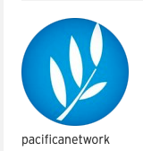
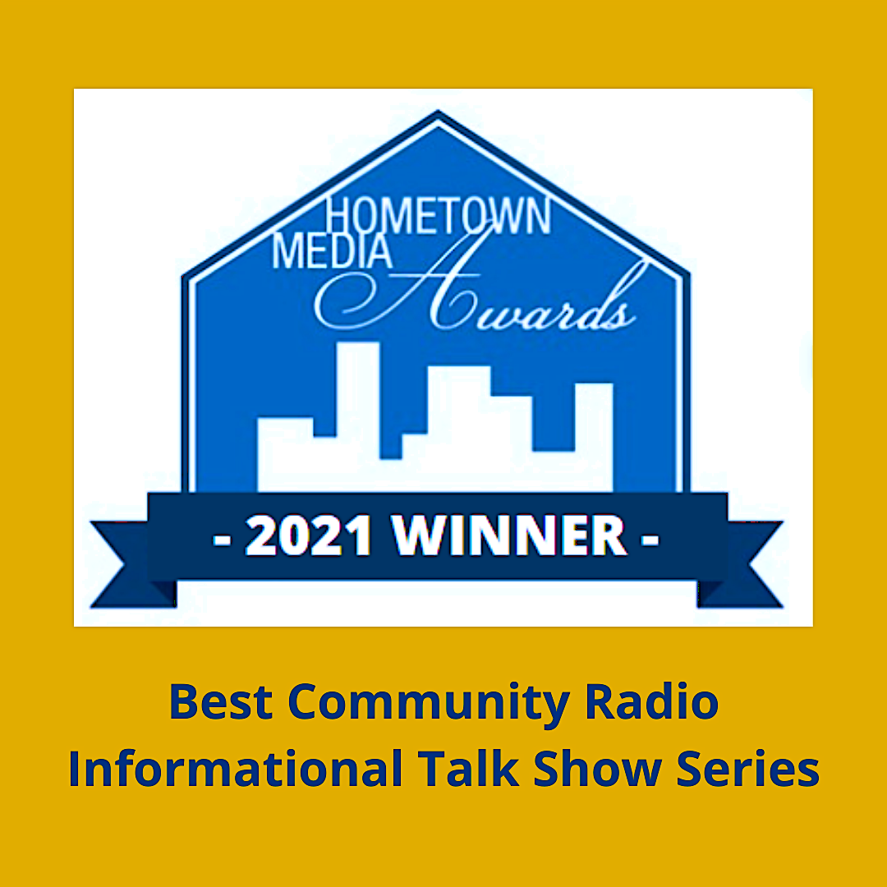
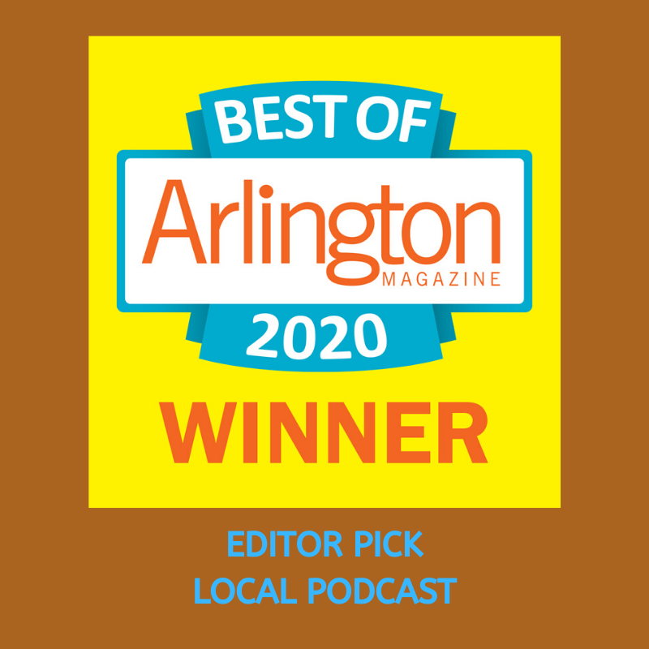
Now syndicated and available via Pacifica Radio Network.

It was my honor and privilege to have been invited by editors Perry Zurn and Arjun Shankar to interview the contributing authors in their anthology Curiosity Studies: A New Ecology of Knowledge (University of Minnesota Press, 2020). These episodes feature the remarkable people behind an exciting volume that seeks to be “enlivening, stimulating and unsettling” and to “enact a radical curiosity in your everyday life.”

- Network Science & the Practice of Curiosity, Danielle Bassett, University of Pennsylvania
- Curiosity & Collecting, with Barbara M. Benedict, Trinity College
- “Why Should This Be So?” with Susan Engel, Williams College
- Ethnography & Cultures of Curiosity, with John L. Jackson Jr., Annenberg School, UPenn
- Neurodiverse Curiosity, with Kristy Johnson, MIT Media Lab
- Curiosity & Racist Mindsets, with Narendra Keval, Consultant Psychotherapist & Clinical Psychologist
- Curious Entanglements, with Christina León, Princeton University
- In Praise of Distraction, with Tyson Lewis, University of North Texas
- Curios & Curiotizing, with Amy Marvin, Trans Scholar
- Capitalist Curiosity & Student Mental Health, with Arjun Shankar, Colgate University
- Reassessing the Costs of Curiosity, with Seeta Sistla, Hampshire College
- Curiosity Studies, Toward a New Ecology of Knowledge, with Perry Zurn, American University

Curiosity is deeply personal and very individual, inviting others into the curiosity conversation opens the dialogue in meaningful – and often delightful – ways. I’ve been pleased to hand the reins to these interns and guest collaborators:

- Curiosity & Sex Ed, with Jacomina de Regt – Caroline Kish, producer & host
- Dance & Embodied Curiosity, with Erin Foreman-Murray, American Univ. – Michela Dwyer, producer& host
- Reading Our Landscapes, with Liam Heneghan, DePaul University – Lydia Perry, producer & host
- Spiritually Curious, with Rev. Bryant Oskvig, American University – Reed Weiler, producer & host
- Curiosity & the Digital Transgender Archive, with KJ Rawson – Matt Ferguson, producer & host
- Imagining Worlds Otherwise: Learning from Black Feminist Curiosity, with Ayanna De'Vante Spencer – Julie Williams-Reyes, producer & host

